**Data Insights on Kickstarter Project Outcomes**

By Steven Jedael

**Overview**

Kickstarter is a crowdfunding service that has raised over two billion dollars for various projects around the world. However, only a third of the roughly 300,000 projects launched through the service have successfully reached or exceeded the funding goal. This report contains insights from the examination of more than four thousand past Kickstarter projects to determine which projects have a high or low chance of a successful funding outcome.

**Key Insights**

1. Some of the most successful funding projects tend to be in the parent category of Music with the sub-categories of Classical Music, Electronic Music, Metal, Pop, and Rock all having 100% successful funding outcomes. Projects in the Faith, Jazz, and World Music sub-categories had 100% failure or cancelation rates in funding outcomes.

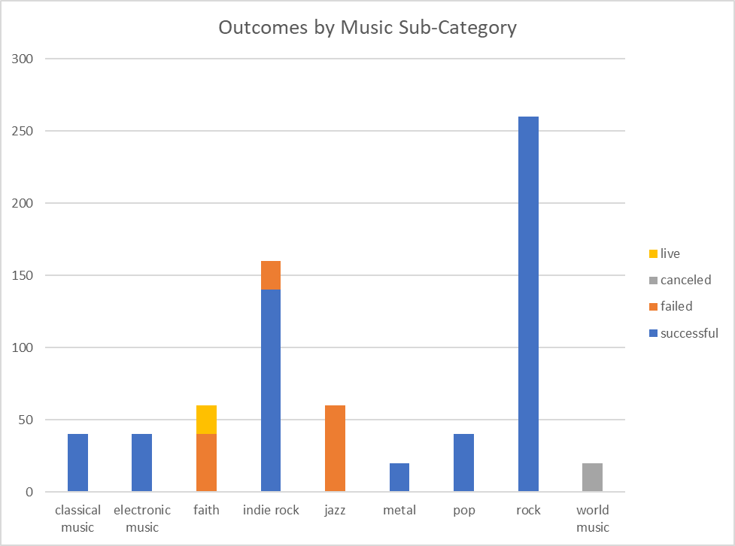

1. In the parent category of Film & Video, funding projects in the sub-categories of Documentary, Shorts, and Television were 100% successful, while those in the sub-categories of Animation, Drama, and Science Fiction had a failure or cancelation rate of 100%.

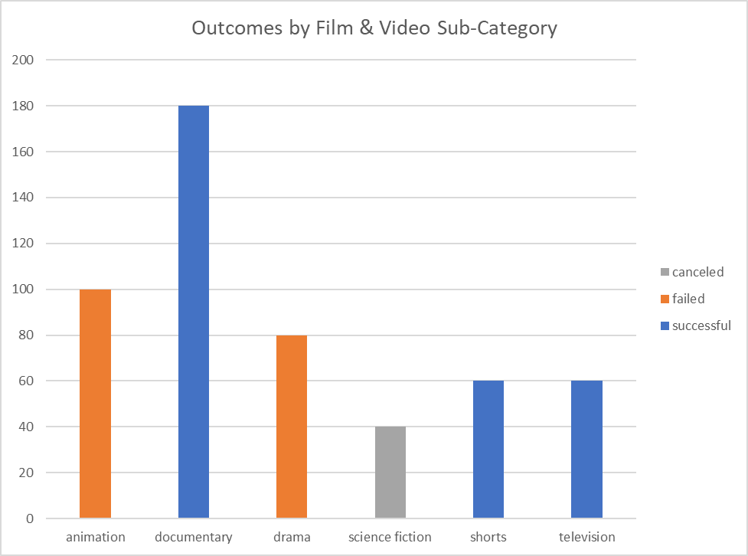

1. Funding projects launched after January and before June have a higher chance of a successful outcome, while December is the worst month to launch a project.

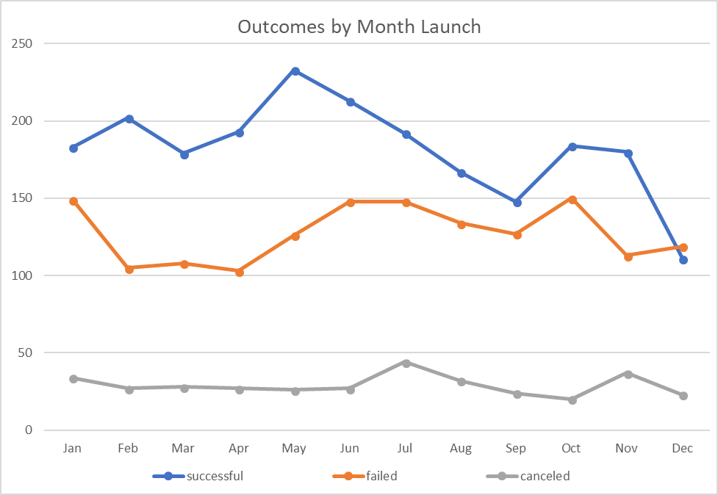

**Data Limitations**

The dataset contains projects from nineteen different countries; however, approximately 74% of these projects were launched in the United States and 20% in Europe. Therefore, the percentage of successful funding projects can be heavily skewed towards popular American interests.

**Further Considerations**

Kickstarter projects have the option of becoming a “Staff Pick” or “Spotlight” project to distinguish them from other projects in a category of sub-category. Another factor to potentially examine is whether a project having a status of “Staff Pick”, “Spotlight”, or both increases its chances of a successful funding outcome.